Crochet Amigurumi Bee

SUPPLIES:  - Yarn  - Yellow (25 yards)  - Black (13 yards)  - White (10 yards)  - Crochet Hook (B/C for fingering/DK weight yarn or E for worsted weight)  - Polyfil (polyester filling, or cotton balls)  - Safety Eyes (or felt or embroidery floss)  - Yarn needle  - Scissors | 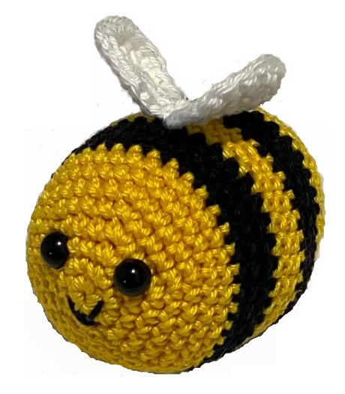
BODY: |  | Helpful hints
Row 1 | Starting with the YELLOW yarn,  6 SC in MR (6 sc) | Create a Magic Ring using the instructions on the “Tips & Tricks” page, and create 6 SC in it.
Row 2 | INC in each SC around (12 sc) | Place 2 SC in each stitch around, resulting in 12 stitches
Row 3 | [SC, INC] 6 times around (18 sc) | 1 SC in the next stitch, 2 SC in the following stitch, 6 times, resulting in 18 stitches
Row 4 | [2 SC, INC] 6 times around (24 sc) | 1 SC in each of the next 2 stitches, then 2 SC in the following stitch, 6 times, resulting in 24 stitches
Row 5 | [3 SC, INC] 6 times around (30 sc) | SC in each of the next 3 stitches, then 2 SC in the following stitch, 6 times, resulting in 30 stitches
Row 6 | SC in each stitch around, SL ST in next stitch, CH 1 (30 sc) | This is changing from crocheting “in the round” in preparation for the seamless color change.
Row 7 | SC in each stitch around, SL ST using Black yarn, CH 1 (30 sc) | SC in each stitch around, SL ST in the top of the beginning stitch using Black yarn
Row 8 | With Black, SC in next 29 stitches, DEC, SL ST, CH 1 (30 sc) | The DEC will be done in the last stitch of this row and the base of the first stitch of the previous row to mask the color change
Row 9 | SC in each stitch around, SL ST in first stitch, CH 1 (30 sc)
Row 10 | SC in each stitch around, SL ST using Yellow yarn, CH 1 (30 sc) | SC in each stitch around, SL ST in the top of the beginning stitch using Yellow yarn
Insert plastic safety eyes where you would like (just above the center, between rows 3 & 4 of stitches. Use black thread to embroider the mouth.
Row 11 | With Yellow, SC in next 29 stitches, DEC, SL ST, CH 1 (30 sc) | The DEC will be done in the last stitch of this row and the base of the first stitch of the previous row to mask the color change.
Row 12 | SC in each stitch around, SL ST in first stitch, CH 1 (30 sc)
Row 13 | SC in each stitch around, SL ST using Black yarn, CH 1 (30 sc) | SC in each stitch around, SL ST in the top of the beginning stitch using Black yarn
Row 14 | With Black, SC in next 29 stitches, DEC, SL ST, CH 1 (30 sc) | The DEC will be done in the last stitch of this row and the base of the first stitch of the previous row to mask the color change
Row 15 | SC in each stitch around, SL ST in first stitch, CH 1 (30 sc)
Row 16 | SC in each stitch around, SL ST using Yellow yarn, CH 1 (30 sc) | SC in each stitch around, SL ST in the top of the beginning stitch using Yellow yarn
Row 17 | With Yellow, SC in next 29 stitches, DEC, SL ST, CH 1 (30 sc) | The DEC will be done in the last stitch of this row and the base of the first stitch of the previous row to mask the color change
Row 18 | SC in each stitch around, SL ST in first stitch, CH 1 (30 sc)
Row 19 | [3 SC, INV DEC] 6 times around (24 sc) | SC in each of the next 3 stitches, then working in the front loop only of the next 2 stitches make invisible decrease, 6 times, resulting in 24 stitches
Row 20 | [2 SC, INV DEC] 6 times around (18 sc) | SC in each of the next 2 stitches, then working in the front loop only of the next 2 stitches make invisible decrease, 6 times, resulting in 18 stitches
Row 21 | [SC, INV DEC] 6 times around (12 sc) | SC in the next stitch, then working in the front loop only of the next 2 stitches decrease, 6 times, resulting in 12 stitches
Add a little extra stuffing before you finish off (if needed)

Row 22 | [INV DEC] 6 times around (6 sc) | Working in the front loop only of the next 2 stitches decrease, 6 times, resulting in 6 stitches
Fasten off, leaving a bit of a long tail… use it to close up the remaining circle of stitches.
WINGS:
Row 1 | Starting with the WHITE yarn,  6 SC in MR (6 sc) | Create a Magic Ring using the instructions below, and create 6 SC in it.
Row 2 | INC in each SC around (12 sc) | Place 2 SC in each stitch around, resulting in 12 stitches
Row 3 | [SC, INC] 6 times around (18 sc) | 1 SC in the next stitch, 2 SC in the following stitch, 6 times, resulting in 18 stitches
Fasten off, leaving a bit of a long tail to attach to the body of the bee. Once both wings are completed, attach them together in 2-3 stitches, then attach them to the body on the middle yellow stripe of the body.
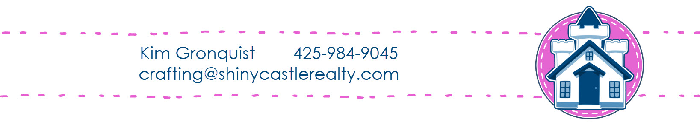

Crochet Tips & Tricks

CH | Chain stitch | Yarn over, pull yarn through loop on hook
SL ST | Slip Stitch | Insert hook into stitch or space, yarn over, pull yarn through both loops on hook.
SC | Single Crochet | Insert hook into stitch or space, yarn over, pull yarn through stitch (resulting in 2 loops on hook), yarn over, pull yarn through both loops on hook.
INC | Increase | Place 2 stitches in the next stitch
DEC | Decrease | Insert hook into the next stitch, yarn over, pull yarn through the stitch (resulting in 2 loops on the hook), insert hook into the next stitch, yarn over, pull yarn through the stitch (resulting in 3 loops on the hook), yarn over and pull through all 3 loops on the hook
INV DEC | Invisible Decrease | Insert hook into the front loop of the next stitch, yarn over, pull yarn through the stitch (resulting in 2 loops on the hook), insert hook into the front loop of the next stitch, yarn over, pull yarn through the stitch (resulting in 3 loops on the hook), yarn over and pull through all 3 loops on the hook.
MR | Magic Ring | Scan for video instructions:

